Replicating Kira’s Figure 4:

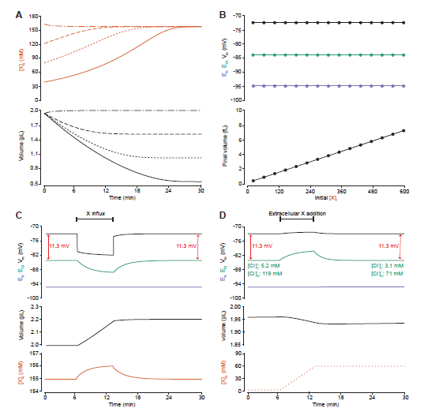

|  |  |
| --- | --- |
| 4a and b - prediction: | Dropping the impermeant anion concentration at the beginning of the simulation will result in a return to steady state with specific values as per analytical solution  X= 155mM  Ecl = -83.8mv  Ek = -95.1mV  Vm = -72.6mV |
| Setup: | 2 compartments  ATPase not Constant  All default values to start with  30 minute runtime  3 trials each with varying X concentrations  Trial 1: X=150  Trial 2: X = 30  Trial 3: X = 480 |
| Trial 1 (x = 150) results: |  |
| Trial 1 (x = 30) results: | Volume shows similar dynamic to Kiras |
| Trial 1 (x = 480) results: |  |
|  |  |
| Conclusion |  |
|  |  |